Below is your first email template. Please use as a guide and change how you feel best reflects your wording.

Please note when you paste this into an email if you could please insert the two hyperlinks into the two videos. Also include your club name where indicated and unique club code.

If you have any issues please view the help guide PDF. Thankyou!

‘Hello Members,

We’re really excited to announce that we’ve secured a very special opportunity for all …. players.

All (Club name) players get FREE access to Horizon Footy Skills, a revolutionary online Aussie Rules Training Program.

The entire program is comprised of daily state-of-the-art videos which are located within an interactive website that tracks & measures your progress.
Please find the launch video and kicking program preview below.

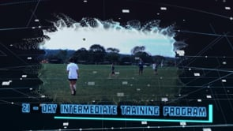
VIDEO ONE VIDEO TWO
https://vimeo.com/416881593/a97ad5a6b7 https://vimeo.com/411018461/c948f54cda
The free access lasts 3 days, where after you’ll have the option to continue or not. If you decided to continue, 10% of every paid membership will go straight back to our club.
The code to get free access is (Your club code) visit www.horizonfootyskills.com.au and get your free membership today.

Have Fun!
Signed Club representative’

