Please find below the template for email two. Again, change wording how you see fit.

Please note when you paste this into an email if you could please insert the video hyperlink at the bottom into the video. Also include your unique club code where marked. Any issues please consult our help guide or contact us. Thanks!

‘Hello Members,

To those who haven’t taken advantage of the FREE 3-day membership offer with Horizon Footy Skills. A reminder that the offer will expire by the end of this week.

By joining you’ll not only get access to a revolutionary Aussie rules training program but if you decide to continue your membership, 10% of your membership fee will go directly to our club.

Some players are really benefiting from the program and have improved their kicking immensely.

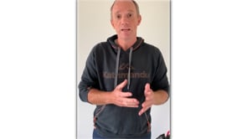

‘The advice on the kicking was so positive, it was amazing the points they brought up I would never have thought about. When the kids implemented those tips, their kicking improved out of sight.'
- Cameron Aubrey Father to Lewis & Fraser

So, if you’re interested and haven’t yet take-up the offer our coupon code is (Your club code), visit www.horizonfootyskills.com.au and get your free membership today.

Cheers,
Signed Club representative’
https://vimeo.com/420145751/db4ffd44eb
(hyperlink to video)

